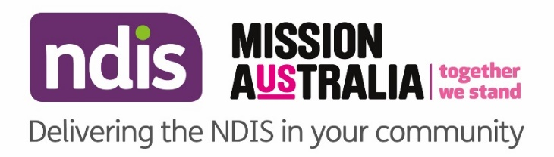


National Disability Insurance Scheme (NDIS)
Community Information

Local Area Coordinators (LAC) in the Community
The Mission Australia Local Area Coordination Service is available to answer your questions about the NDIS and to help link you to mainstream and community supports. Local Area Coordinators will be available each week to answer your questions about the NDIS on an individual basis.

We are inviting people to meet with a Local Area Coordinator (LAC) who can help with:
- How to access the NDIS
- How to prepare for your NDIS planning
- How to understand and use your NDIS plan
- How to manage the budgets in your plan
- How to find and engage providers to help you meet your goals
- How to link to mainstream and community services

LAC in the Community
Monday | 9.00am to 12.00noon, Katharine Susannah Prichard Library, 134 Scott Street Boya
Tuesday | 9.00am to 11.00am, Ellenbrook Community Library, Main Street Ellenbrook
Wednesday | 9.00am to 12.00noon, (CLAN) Midvale Community Centre, 44 Mathoura Street Midland
Thursday | 9.00am to 12.00noon, Ethel Warren Community Centre, Maroubra Avenue Bullsbrook
Thursday | 10.00am to 2.00pm, Alice Davoren Centre, Titus Road Lockridge
Friday | 9.00am to 11.00am, Ellenbrook Community Library, Main Street Ellenbrook

Arrangements can be made to support people who require interpreters or who have specific cultural requirements, please call 1800 370 776 prior to your visit.

Carers Mental Health Support Program – free sessions available
If you support someone with a mental health condition or illness, you can access up to 10 free sessions with an experienced mental health professional to assist you in this important role. Male and female mental health practitioners are available for appointments from Monday to Saturday at Pease Street Therapy Centre, 13 Pease St, Manoora until June 2020.

The program is fully- funded and any carer may self-refer via email to restedminds1@gmail.com.

