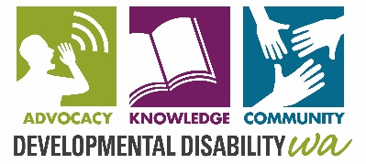
DEVELOPMENTAL DISABILITY COUNCIL OF WA (INC)
Trading as Developmental Disability WA

BOARD NOMINATON FORM

Name of member being nominated: _________________________________________________

Name of organisation represented (if applicable): ______________________________________

Position nominated for: Chairperson, Vice Chairperson, Treasurer, Secretary, Board Member

______________________________________________________________________________
Signature of Nominee Date

Nominated by: __________________________________________________________________

______________________________________________________________________________
Signature of Nominator Date

Conditions of Election:
- Nominees (or the Organisation they represent) must be current members of DDWA,
- At any time, there must be no more than 4 Organisation members on the board,
- There are two board positions becoming vacant at the 2020/2021 Annual General Meeting;
- Nominations must be posted/delivered/emailed to the DDWA office by 5pm, 14 Aug 2020.

Developmental Disability WA,
City West Lotteries House,
2 Delhi Street,
West Perth WA 6005 or email to ddwa@ddwa.org.au

Please provide a brief profile of the skills and experience you could offer the DDWA Board. Note - This profile will be circulated to DDWA members prior to the Annual General Meeting.

Please contact Mary Butterworth, Chief Executive Officer, Ph: 9420 7230, if you would like to discuss nominating for a board position.

