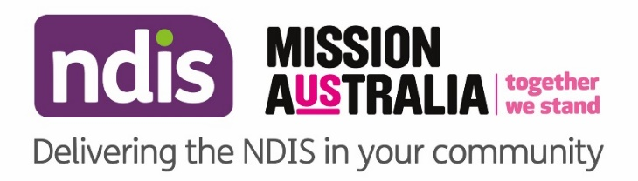

NOW IN BASSENDEAN

National Disability Insurance Scheme (NDIS)
Community Information

Local Area Coordinators (LAC) in the Community
The Mission Australia Local Area Coordination Service is available to answer your questions about the NDIS and to help link you to mainstream and community supports. Local Area Coordinators will be available each week to answer your questions about the NDIS on an individual basis.

We are inviting people who live in the Bassendean area to meet with a Local Area Coordinator (LAC) who can help with:
- How to access the NDIS
- How to prepare for your NDIS planning
- How to understand and use your NDIS plan
- How to manage the budgets in your plan
- How to find and engage providers to help you meet your goals
- How to link to mainstream and community services

LAC in the Community
Wednesday 26 August
Wednesday 9 September
Wednesday 23 September
Wednesday 7 October
Wednesday 21 October

Time
9.30pm – 3.30pm

Location

Bassedean Memorial Library, 46 Old Perth Rd, Bassendean WA 6054

Arrangements can be made to support people who require interpreters or who have specific cultural requirements, please call 1800 370 776 prior to your visit.

